**Assignment No. 14**

**Problem statement:**

Create an Elastic IP for an Instance.

**Solution:**

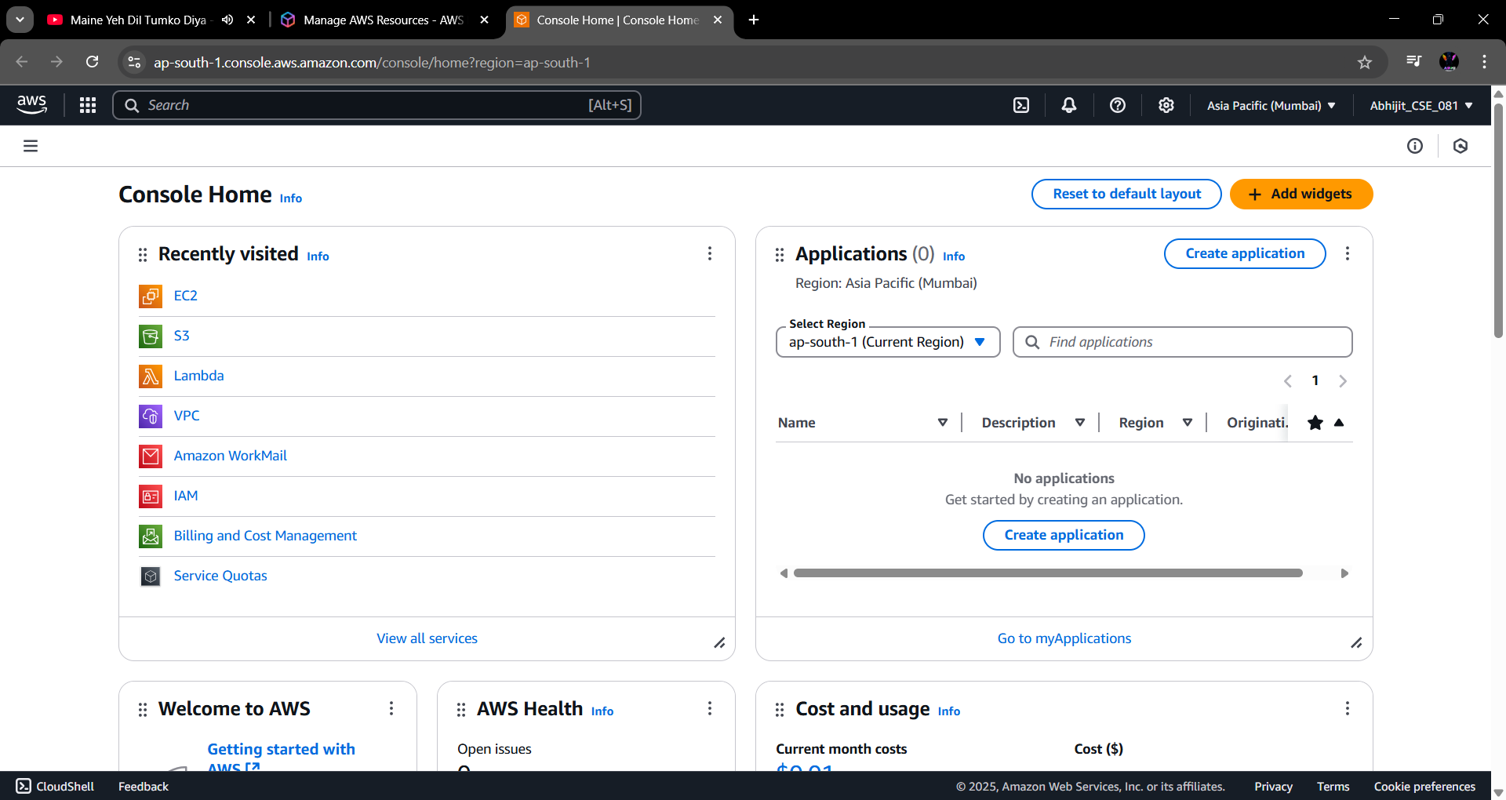**Step 1:** Go to **“EC2”** from the AWS home screen.

**Step 2:** From the left side menu, go to **“Instances”** and click on ‘**Lunch Instance**’**.**

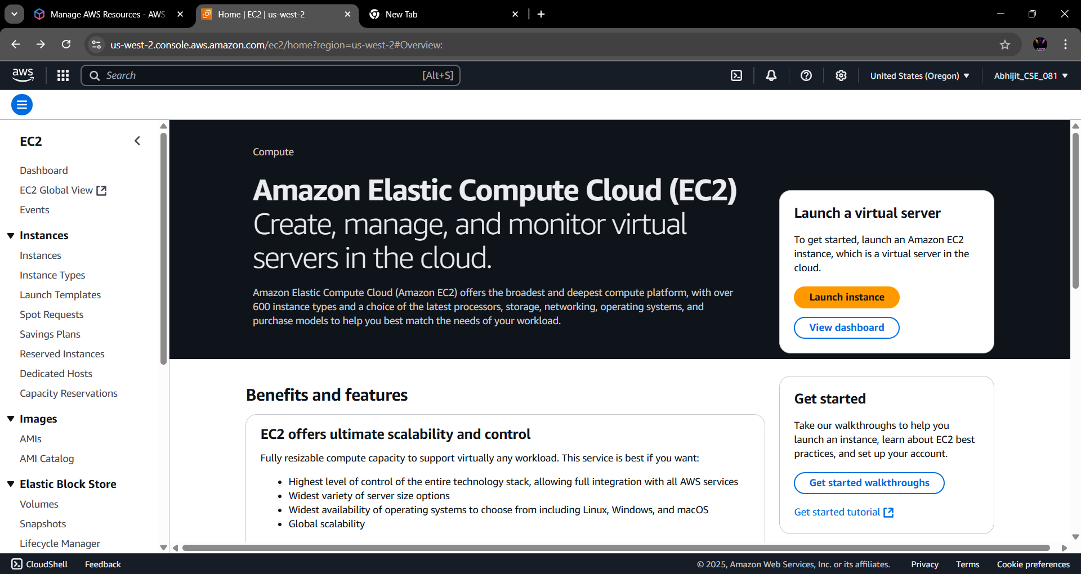

**Step 3:** Create an Instance (Give Instance **Name**, Application & OS as ‘**Ubuntu**’, instance type as ‘**t2. micro’**, Select Key pair, Create Security group select all traffic and Click on Lunch Instance) **Save** its Public IPv4 address in a text file for future comparison.

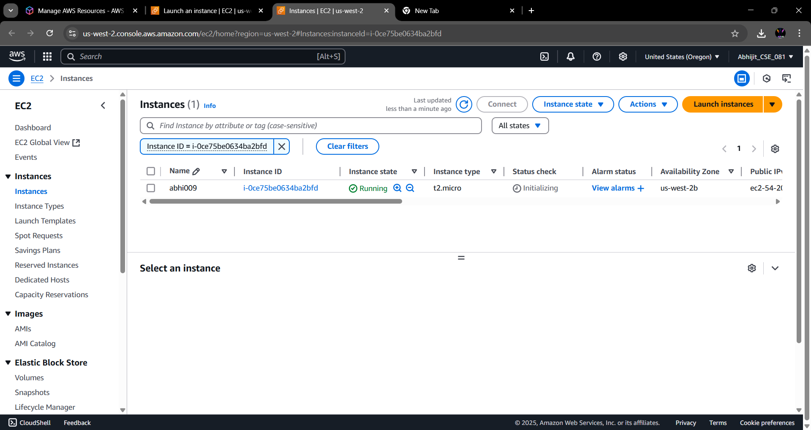

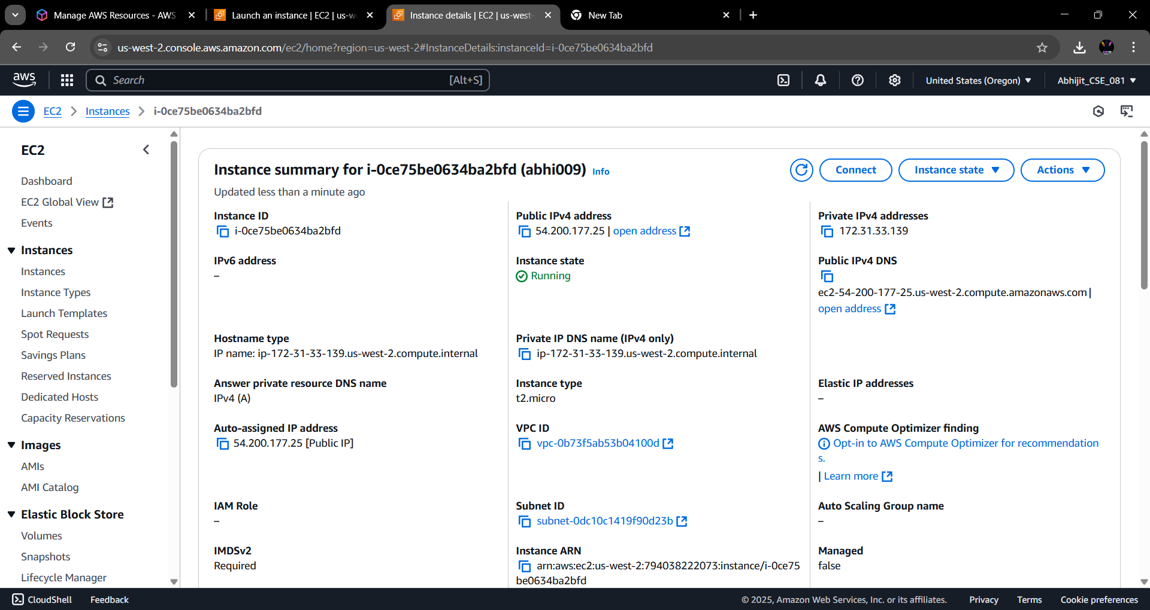**Step 4:** With the instance selected, open the Instance State dropdown menu and select **“Stop Instance”** option to temporarily put the instance in the sleep state. After a while again start this instance.



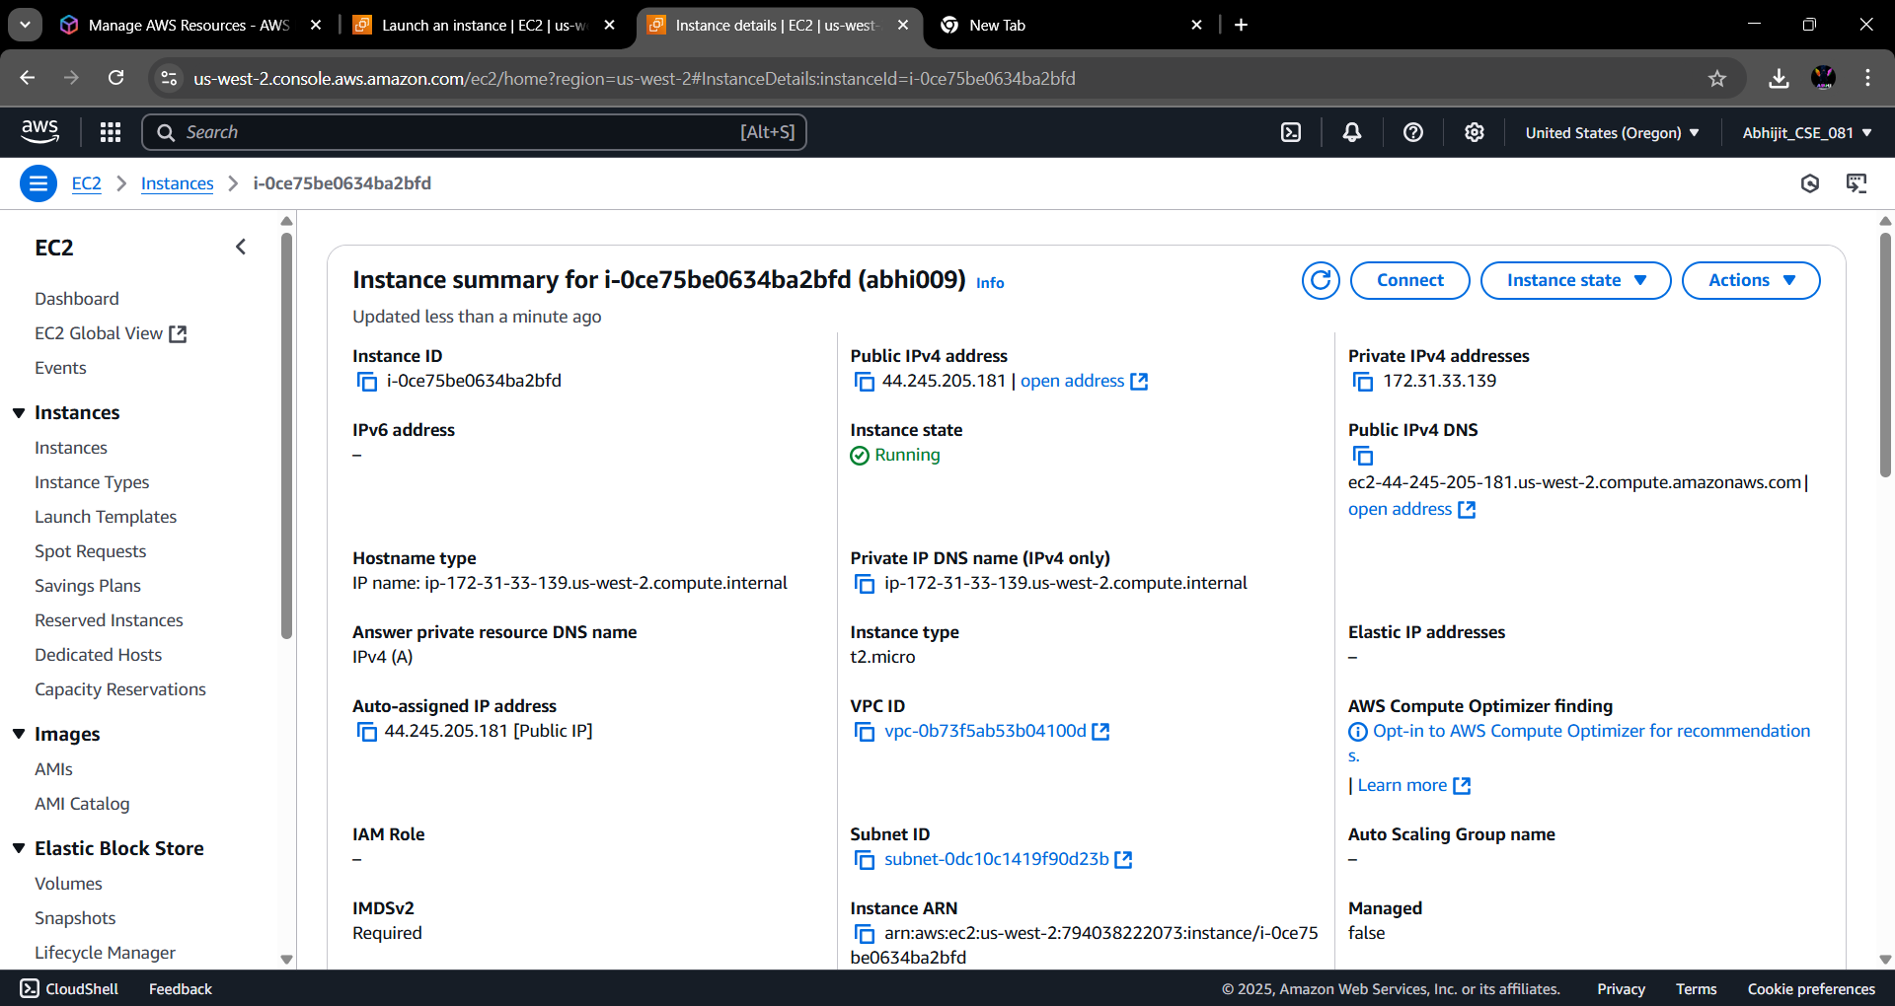**Step 5:** Now again save the Public IPv4 address in the text file and compare it with the previous IP.

It is evident that the IP address changes every time the instance is launched. To avoid it Elastic IP has to be assigned.

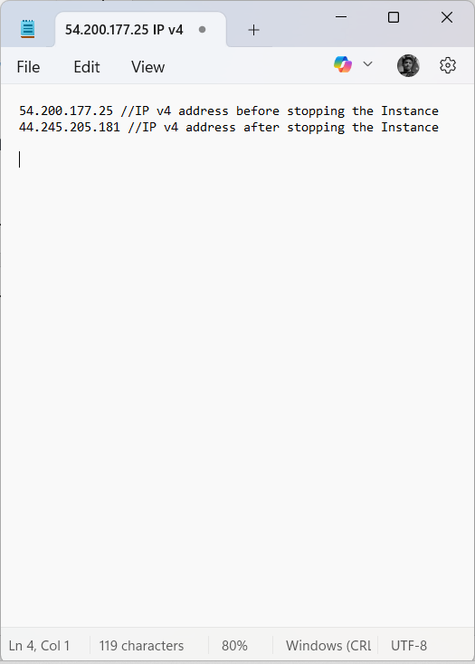

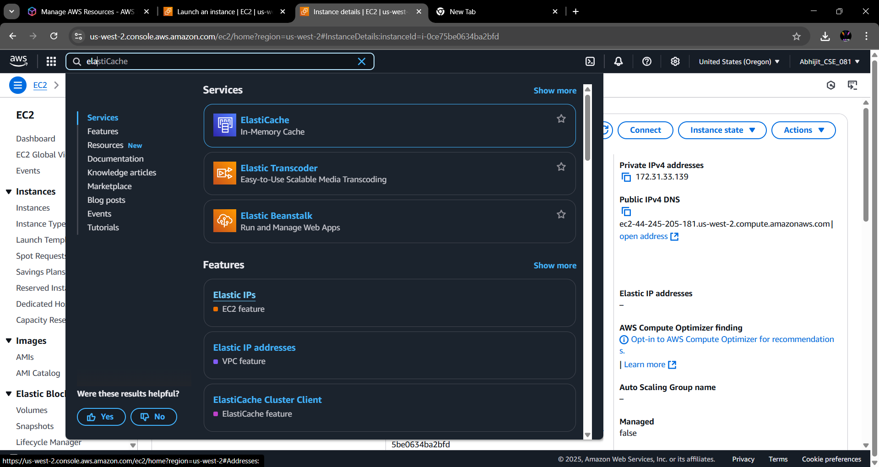**Step 6:** From the EC2 Dashboard, go to the **“Elastic IP’s”** option.

**Step 7:** Click on **“Allocate Elastic IP”** button on the top right corner of the screen.

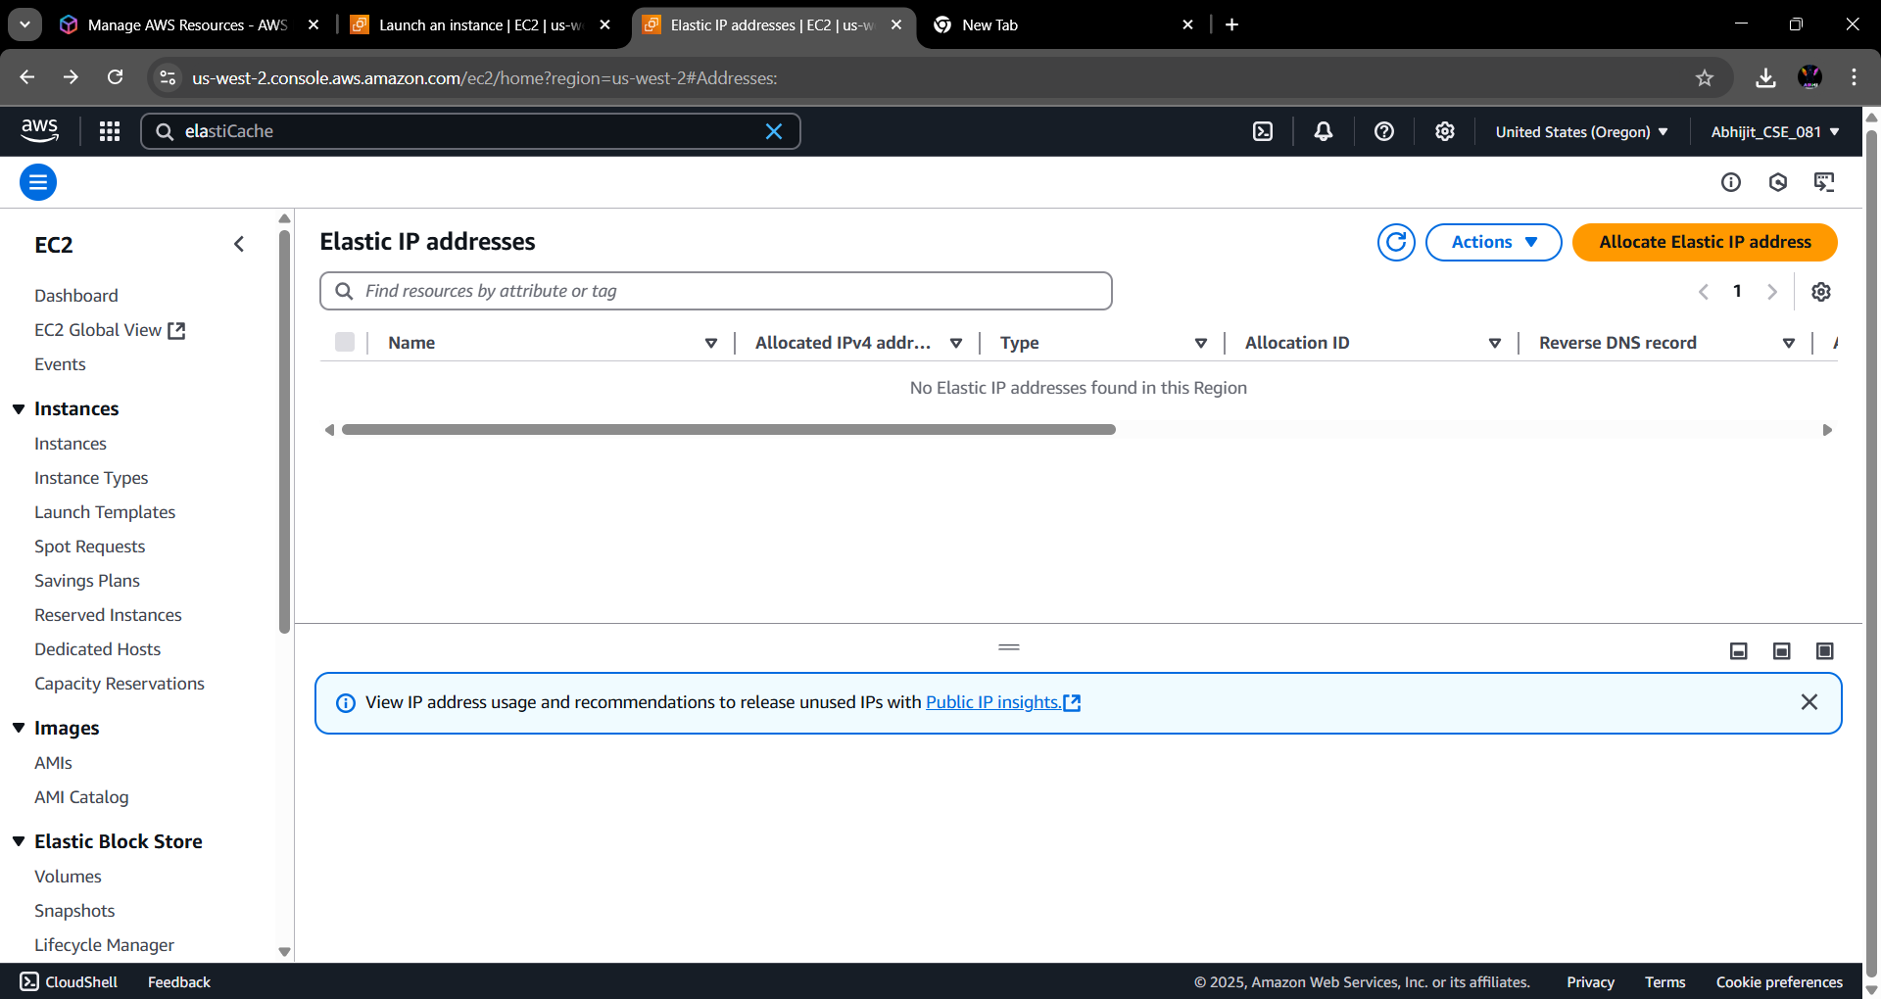

**Step 8:** With **“Amazon’s pool of IPv4 Addresses”** selected under Public IPv4 Address pool, click on **“Allocate”.**

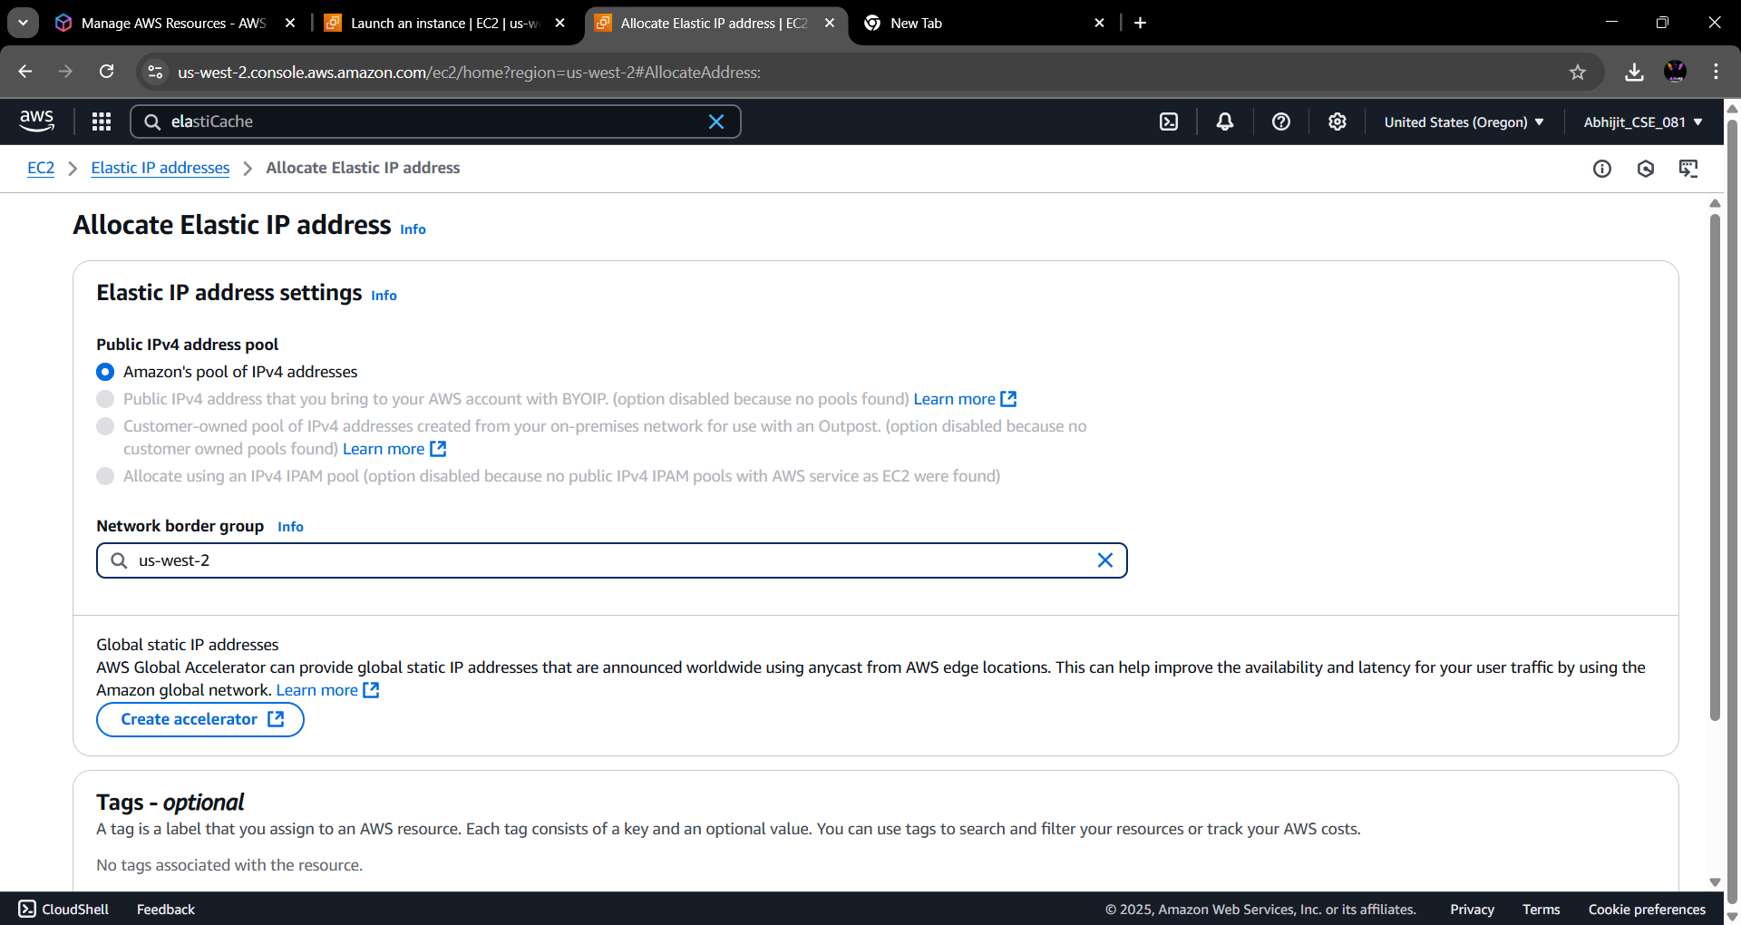

**Step 9:** The Elastic IP has been created. Click on the IP to open it.

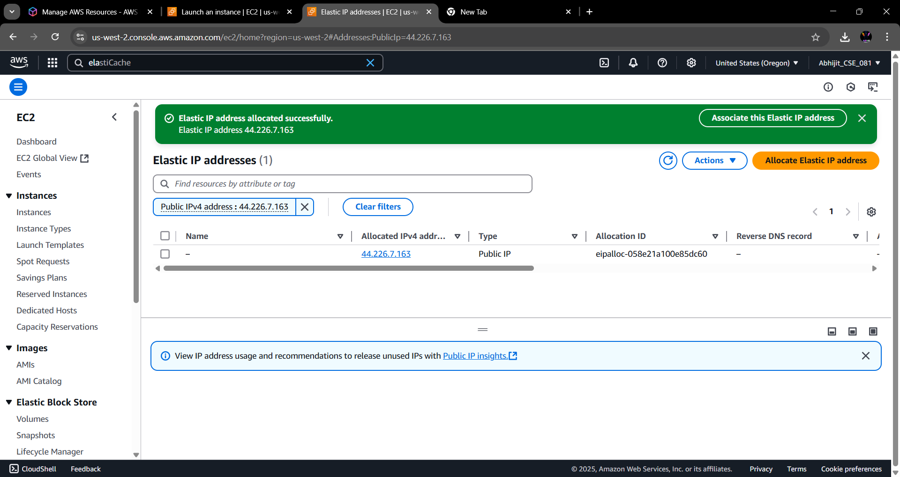 **Step 10:** Click on **“Associate Elastic IP Address”**.



**Step 11:** With resource type selected as **“Instance”,** select the name of the instance & its private IP address. Check the bottom checkbox to reassociation the Elastic IP. Then click on **“Associate”**.

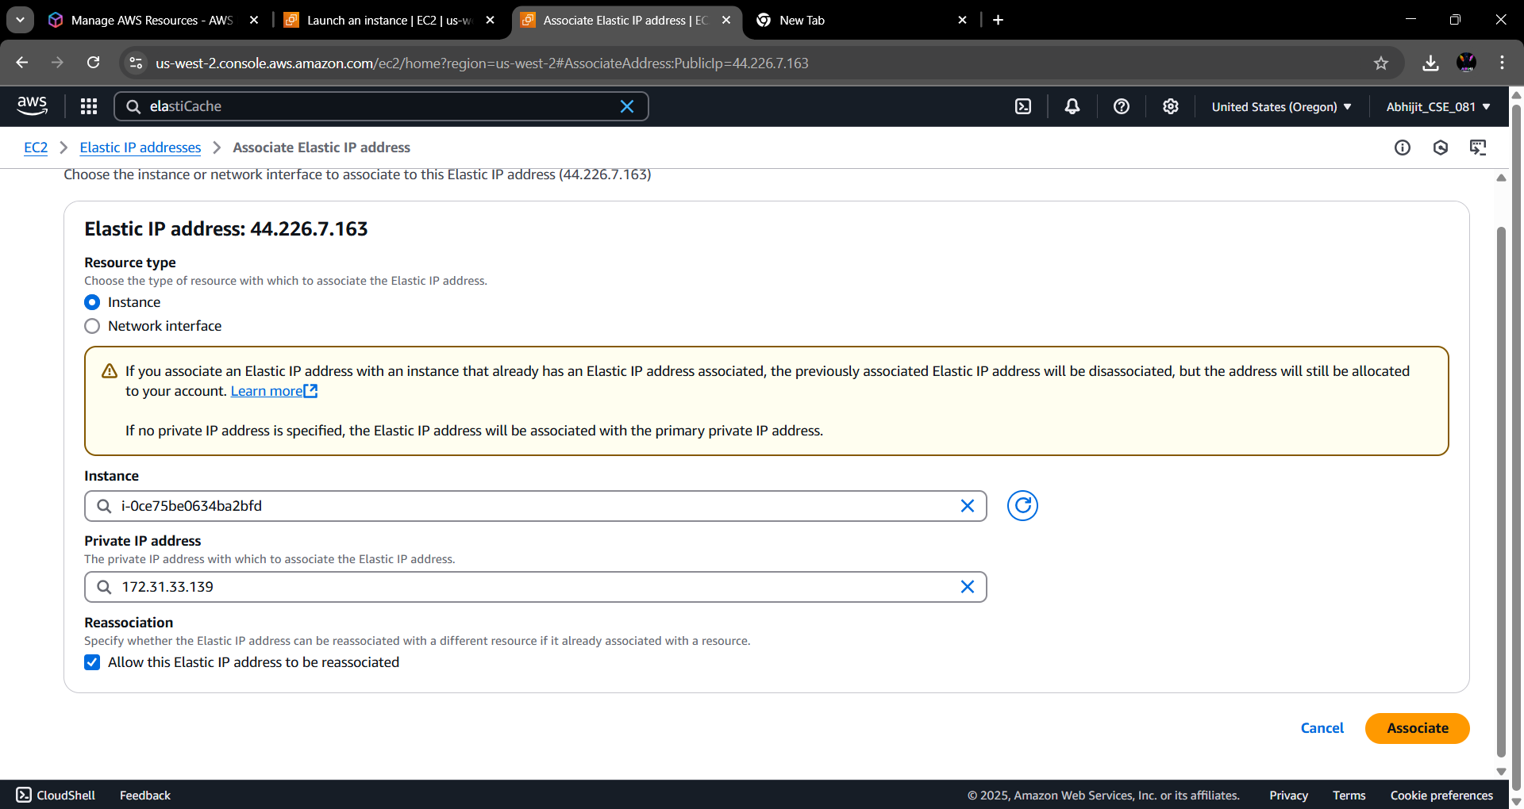

**Step 12:** Repeat **Step 4** and copy the IPv4 address before selecting **“Stop Instance”** and again start this instance and copy the IPv4 address. No changes are observed.

